**CSUEB – STAT 6305 – Winter 2017 - Prof Yan Zhou**

**Homework 8 - Henry Lankin**

March 16, 2017

**HW 8: 1, 17.21, 18.13, 18.14**

Eight healthy male subjects participated in a food interaction study to evaluate the magnitude of the food interaction of a new hypertensive therapy, Drug P, and its metabolite, Drug M. Four subjects (numbers 1, 2, 5, 7) were randomized to take Drug P with food(Fed) in the first treatment period but without food (Fasted) in the second treatment period. The other four subjects (numbers 3, 4, 6, 8) took Drug P without food in the first treatment period but with food in the second treatment period. Drug concentration values were assayed from plasma samples taken at 0, 10, 20, 30, 40, and 50 minutes, and 1, 1.25, 1.5, 1.75, 2, 3, 4, 5, 6, 8, 10, 12, 18, 24, 30, and 36 hours after dosing. AUC (areas under the concentration curve) was estimated from zero hours to 36 hours using the PK(Pharmacokinetic) sample data above. The data is listed below. Sequence 1: +/-, Sequence 2: -/+.

|  |  |  |  |
| --- | --- | --- | --- |
| **Subject** | **Sequence** | **AUC, fed** | **AUC, fasted** |
| $$1$$ | $$1$$ | $$809.44$$ | $$967.82$$ |
| $$2$$ | $$1$$ | $$428$$ | $$746.45$$ |
| $$3$$ | $$2$$ | $$757.71$$ | $$901.11$$ |
| $$4$$ | $$2$$ | $$906.83$$ | $$1146.96$$ |
| $$5$$ | $$1$$ | $$712.24$$ | $$678.16$$ |
| $$6$$ | $$2$$ | $$561.77$$ | $$745.51$$ |
| $$7$$ | $$1$$ | $$511.84$$ | $$568.98$$ |
| $$8$$ | $$2$$ | $$756.6$$ | $$852.86$$ |

1. Plot the mean AUC by period for each sequence. Identify the study design.

This is a cross over design with two periods, 8 subjects, two possible treatments (fed or fasted) and a total of 16 observations. The response variable is the AUC estimation for each treatment-period combination. The table below shows the sequence description.

|  |  |  |
| --- | --- | --- |
| **Sequence** | **Period 1** | **Period 2** |
| $$1$$ | $$fed$$ | $$fasted$$ |
| $$2$$ | $$fasted$$ | $$fed$$ |

Below is the interaction plot showing the mean AUC by period for each sequence.

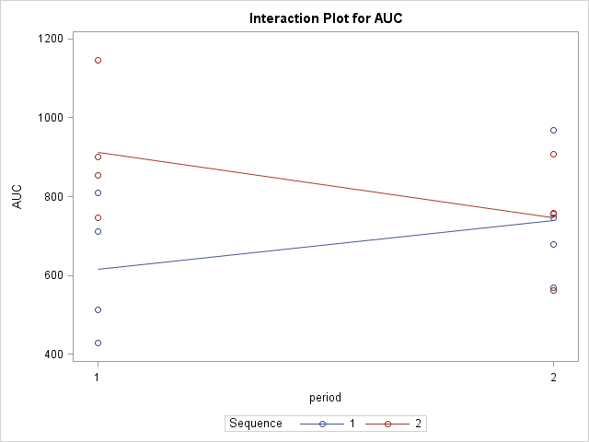

1. Write the ANOVA model for this study. Include all appropriate main effects and interactions. Explain what each symbol in the model means. Designate each effect as either fixed or random. Indicate the ranges of subscripts. State the assumptions for this model.

Crossover design model with a random effect:

$$y_{ijkl}=μ+δ_{i}+β_{j\left(i\right)}+γ_{k}+τ_{l}{+ε}_{ijkl}$$

$$i=1, 2; j=1, 2,…,8; k=1, 2; l=1,2$$

$y_{ijkl}$– the AUC estimation of the $j^{th}$ patient in the $i^{th}$ sequence from the $k^{th}$ period representing the observed response variable: 16 observations

$μ$– overall mean AUC estimation.

$δ_{i}$– the fixed effect due to the $i^{th}$ sequence: 2 sequence levels, +/- or -/+

$β_{j(i)}$– the random effect due to the $j^{th}$ subject in the $i^{th}$ sequence: indices are $j\left(i\right)=1(1), 2(1), 5(1), 7(1), 3(2), 4(2), 6(2), 8(2)$*.* Assumed to be independent of each other and follow $N(0,σ_{β}^{2})$.

$γ_{k}$– the fixed effect due to the $k^{th}$ fixed time periods: 2 period levels

$τ_{l}$– the fixed effect due the $l^{th}$ treatment level: 2 treatment levels, fed or fasted

$ε_{ijk}$– random error associated with each observation: 16 residual errors. Assumed to be independent of each other and follow $N(0,σ_{ε}^{2})$.

1. Perform the analysis of variance in accordance with your model in part (b). Write down the results below.

|  |  |  |  |  |  |
| --- | --- | --- | --- | --- | --- |
| **Source** | **DF** | **Type III SS** | **Mean Square** | **F Value** | **Pr > F** |
| **sequence** | $$1$$ | $$90966$$ | $$90966$$ | $$1.92$$ | $$0.2154$$ |
| **subject(sequence)** | $$6$$ | $$284668$$ | $$47445$$ | $$7.15$$ | $$0.0152$$ |
| **period** | $$1$$ | $$1673.628100$$ | $$1673.628100$$ | $$0.25$$ | $$0.6334$$ |
| **treatment** | $$1$$ | $$84597$$ | $$84597$$ | $$12.75$$ | $$0.0118$$ |
| **Error** | $$6$$ | $$39816$$ | $$6636.073896$$ |  |  |

1. Does food appear to have an effect on the AUC of the new hypertensive therapy at the $α=0.05$ level of significance? Justify your answer.

Hypotheses to test the effect of food on mean AUC estimation, a fixed effect:

$$H_{0}:τ_{1}=τ_{2}=0$$

$$H_{a}:At least one τ_{l} differs from 0$$

From the table in part (c), we see that, for the treatment effect, $p$-value $=0.0118<0.05$. Thus, we reject the null hypothesis that the mean AUC estimation is equal between the treatment levels and conclude that food has a significant effect on the mean AUC estimation.

1. Is there evidence of a period effect? Justify your answer.

Hypotheses to test the effect of period on mean AUC estimation, a fixed effect:

$$H_{0}:γ_{1}=γ_{2}=0$$

$$H_{a}:At least on γ_{k} differs from 0$$

From the table in part (c), we see that, for the treatment effect, $p$-value $=0.6334>0.05$. Thus, we fail to reject the null hypothesis that the mean AUC estimation is equal between the period levels and conclude that period does not have a significant effect on the mean AUC estimation.

17.21

A study was designed to evaluate the effectiveness of new treatments to reduce the systolic blood pressure of patients determined to have high blood pressure. Three drugs were selected for evaluation (D1, D2, D3). There are numerous nondrug treatments for reducing blood pressure, including various combinations of a controlled diet, exercise programs, biofeedback, and so on. The researchers randomly selected three nondrug treatments (ND1, ND2, ND3) for examination in the study. The age of the patient often may hinder the effectiveness of any treatment. Thus, patients with high blood pressure were divided into two age groups (A1, A2). A group of 54 patients was di- vided into the two age groups and then randomly assigned to a combination of one of the three drugs and one of the three nondrug treatments. After participating in the program for 2 months, the reduction in systolic blood pressure from the blood pressure readings at the beginning of the pro- gram was recorded for each patient. These values are given in the following table.

1. Write a model for this study. Identify all terms in your model and state all necessary conditions placed on the terms in the model.

Nested design model with a single random effect:

$$y_{ijkl}=μ+τ_{i}+β_{j}+γ_{k(i)}+{βγ}_{jk(i)}{+ε}_{ijkl}$$

$$i=1, 2; j=1, 2,3; k=1, 2,3; l=1,2,3$$

$y_{ijkl}$– the blood pressure reduction of the $l^{th}$ replication of the $j^{th}$ drug treatment and the $k^{th}$ non-drug treatment in the $i^{th}$ age group, representing the observed response variable: 54 observations

$μ$– overall mean blood pressure reduction.

$τ_{i}$– the major fixed effect due to the $i^{th}$ age: 2 age levels, A1 and A2

$β_{j}$– the major fixed effect due to the $j^{th}$ drug in the $i^{th}$ sequence: 3 drug levels, D1, D2, and D3

$γ_{k(i)}$– the random minor effect due to the $k^{th}$ non-drug treatment: 3 non-drug levels, ND1, ND2, and ND3. Assumed to be independent of each other and follow $N(0,σ_{γ}^{2})$.

${βγ}_{jk(i)}$– the random interaction effect due the $j^{th},k^{th}$ drug-non-drug treatment combination: 9 interaction combination levels. Assumed to be independent of each other and follow $N(0,σ_{βγ}^{2})$.

$ε_{ijk}$– random error associated with each observation: 54 residual errors. Assumed to be independent of each other and follow $N(0,σ_{ε}^{2})$.

1. Construct the AOV table for the study, including the expected mean squares.

|  |  |  |  |  |  |  |
| --- | --- | --- | --- | --- | --- | --- |
| **Source** | **DF** | **Type III SS** | **Mean Square** | **EMS** | **F Value** | **Pr > F** |
| **Age** | $$1$$ | $$52.018519$$ | $$52.018519$$ | $$σ_{ε}^{2}+3σ_{βγ(τ)}^{2}+9σ_{γ(τ)}^{2}+{27θ}_{τ}$$ | $$0.77$$ | $$0.4309$$ |
| **Drug** | $$2$$ | $$431.370370$$ | $$215.685185$$ | $$σ_{ε}^{2}+3σ_{βγ(τ)}^{2}+{9θ}_{β}$$ | $$4.55$$ | $$0.0392$$ |
| **Non(Age)** | $$4$$ | $$271.629630$$ | $$67.907407$$ | $$σ_{ε}^{2}+3σ_{βγ(τ)}^{2}+9σ_{γ(τ)}^{2}$$ | $$1.43$$ | $$0.2925$$ |
| **Drug*Non(Age)** | $$10$$ | $$473.518519$$ | $$47.351852$$ | $$σ_{ε}^{2}+3σ_{βγ(τ)}^{2}$$ | $$14.87$$ | $$<.0001$$ |
| **Error** | $$36$$ | $$114.666667$$ | $$3.185185$$ | $$σ_{ε}^{2}$$ |  |  |

1. Test the significance of all relevant sources of variation. Use $α=0.05$.

The major effect of age is insignificant. Although, the minor effect of non-drug alone is insignificant, the interaction between drug and non-drug is significant. Lastly, the major effect of drug is significant.

1. What conclusions do you draw about the difference in the effectiveness of the combinations of nondrug and drug treatments for high blood pressure?

|  |  |  |  |  |  |
| --- | --- | --- | --- | --- | --- |
| **Parameter** | **Estimate** |  | **Standard Error** | **t Value** | **Pr > |t|** |
| **Intercept** | 36.33333333 | B | 1.03040206 | 35.26 | <.0001 |
| **Age A1** | -0.33333333 | B | 1.45720856 | -0.23 | 0.8204 |
| **Age A2** | 0.00000000 | B | . | . | . |
| **Drug D1** | 10.00000000 | B | 1.45720856 | 6.86 | <.0001 |
| **Drug D2** | 7.33333333 | B | 1.45720856 | 5.03 | <.0001 |
| **Drug D3** | 0.00000000 | B | . | . | . |
| **Non(Age) ND1 A1** | 0.33333333 | B | 1.45720856 | 0.23 | 0.8204 |
| **Non(Age) ND2 A1** | 8.66666667 | B | 1.45720856 | 5.95 | <.0001 |
| **Non(Age) ND3 A1** | 0.00000000 | B | . | . | . |
| **Non(Age) ND1 A2** | 0.33333333 | B | 1.45720856 | 0.23 | 0.8204 |
| **Non(Age) ND2 A2** | 9.33333333 | B | 1.45720856 | 6.40 | <.0001 |
| **Non(Age) ND3 A2** | 0.00000000 | B | . | . | . |
| **Drug*Non(Age) D1 ND1 A1** | -12.33333333 | B | 2.06080411 | -5.98 | <.0001 |
| **Drug*Non(Age) D1 ND2 A1** | -17.66666667 | B | 2.06080411 | -8.57 | <.0001 |
| **Drug*Non(Age) D1 ND3 A1** | -5.33333333 | B | 2.06080411 | -2.59 | 0.0138 |
| **Drug*Non(Age) D2 ND1 A1** | 2.00000000 | B | 2.06080411 | 0.97 | 0.3383 |
| **Drug*Non(Age) D2 ND2 A1** | -5.00000000 | B | 2.06080411 | -2.43 | 0.0204 |
| **Drug*Non(Age) D2 ND3 A1** | 0.66666667 | B | 2.06080411 | 0.32 | 0.7482 |
| **Drug*Non(Age) D3 ND1 A1** | 0.00000000 | B | . | . | . |
| **Drug*Non(Age) D3 ND2 A1** | 0.00000000 | B | . | . | . |
| **Drug*Non(Age) D3 ND3 A1** | 0.00000000 | B | . | . | . |
| **Drug*Non(Age) D1 ND1 A2** | -11.66666667 | B | 2.06080411 | -5.66 | <.0001 |
| **Drug*Non(Age) D1 ND2 A2** | -9.33333333 | B | 2.06080411 | -4.53 | <.0001 |
| **Drug*Non(Age) D1 ND3 A2** | 0.00000000 | B | . | . | . |
| **Drug*Non(Age) D2 ND1 A2** | 3.00000000 | B | 2.06080411 | 1.46 | 0.1541 |
| **Drug*Non(Age) D2 ND2 A2** | -7.00000000 | B | 2.06080411 | -3.40 | 0.0017 |
| **Drug*Non(Age) D2 ND3 A2** | 0.00000000 | B | . | . | . |
| **Drug*Non(Age) D3 ND1 A2** | 0.00000000 | B | . | . | . |
| **Drug*Non(Age) D3 ND2 A2** | 0.00000000 | B | . | . | . |
| **Drug*Non(Age) D3 ND3 A2** | 0.00000000 | B | . | . | . |
| **Age*Drug A1 D1** | 0.00000000 | B | . | . | . |
| **Age*Drug A1 D2** | 0.00000000 | B | . | . | . |
| **Age*Drug A1 D3** | 0.00000000 | B | . | . | . |
| **Age*Drug A2 D1** | 0.00000000 | B | . | . | . |
| **Age*Drug A2 D2** | 0.00000000 | B | . | . | . |
| **Age*Drug A2 D3** | 0.00000000 | B | . | . | . |

18.13

An investigational drug product was studied under sleep laboratory conditions to determine its effect on duration of sleep. A group of 16 patients willing to participate in the study were randomly assigned to one of two drug sequences; 8 were to receive the investigational drug in period 1 and an identical-appearing placebo in period 2, and the remaining 8 patients were to receive the treatment in the reverse order.

1. Identify the design.

This is a crossover design with 32 total observations, two levels of sequence,

1. Give a model for this design.

$$y_{ijkl}=μ+δ_{i}+β_{j\left(i\right)}+γ_{k}+τ_{l}{+ε}_{ijkl}$$

$$i=1, 2; j=1, 2,…,8; k=1, 2; l=1,2$$

$y_{ijkl}$– the sleep duration of the $j^{th}$ patient in the $i^{th}$ sequence from the $k^{th}$ period representing the observed response variable: 32 observations

$μ$– overall mean sleep duration.

$δ_{i}$– the fixed effect due to the $i^{th}$ sequence: 2 sequence levels, drug-placebo and placebo-drug

$β_{j(i)}$– the random effect due to the $j^{th}$ subject in the $i^{th}$ sequence: 16 subjects split randomly and equally between the two sequences. Assumed to be independent of each other and follow $N(0,σ_{β}^{2})$.

$γ_{k}$– the fixed effect due to the $k^{th}$ fixed time periods: 2 period levels

$τ_{l}$– the fixed effect due the $l^{th}$ treatment level: 2 treatment levels, drug or placebo.

$ε_{ijk}$– random error associated with each observation: 32 residual errors. Assumed to be independent of each other and follow $N(0,σ_{ε}^{2})$.

1. State the assumptions that might affect the appropriateness of this design.

Assumptions are stated in part (b).

18.14

Sleep duration data (in hours/night) are shown for the patients of Exercise 18.13. Sequence 1 received the investigational drug first and placebo second; the reverse order applied to sequence 2.

1. Compute means and standard errors per sequence, per period.

|  |  |  |  |  |  |
| --- | --- | --- | --- | --- | --- |
| **Parameter** | **Estimate** |  | **Standard Error** | **t Value** | **Pr > |t|** |
| **Intercept** | $$7.537500000$$ | $$B$$ | $$0.27266664$$ | $$27.64$$ | $$<.0001$$ |
| **Period 1** | $$-0.387500000$$ | $$B$$ | $$0.38560886$$ | $$-1.00$$ | $$0.3235$$ |
| **Period 2** | $$0.000000000$$ | $$B$$ | $$.$$ | $$.$$ | $$.$$ |
| **Sequence 1** | $$-0.687500000$$ | $$B$$ | $$0.38560886$$ | $$-1.78$$ | $$0.0854$$ |
| **Sequence 2** | $$0.000000000$$ | $$B$$ | $$.$$ | $$.$$ | $$.$$ |
| **Period*Sequence 1 1** | $$0.862500000$$ | $$B$$ | $$0.54533329$$ | $$1.58$$ | $$0.1250$$ |
| **Period*Sequence 1 2** | $$0.000000000$$ | $$B$$ | $$.$$ | $$.$$ | $$.$$ |
| **Period*Sequence 2 1** | $$0.000000000$$ | $$B$$ | $$.$$ | $$.$$ | $$.$$ |
| **Period*Sequence 2 2** | $$0.000000000$$ | $$B$$ | $$.$$ | $$.$$ | $$.$$ |

1. Plot these data to show what happened during the study. Does the investigational drug appear to affect sleep duration? In what way? Use $α=0.05$.

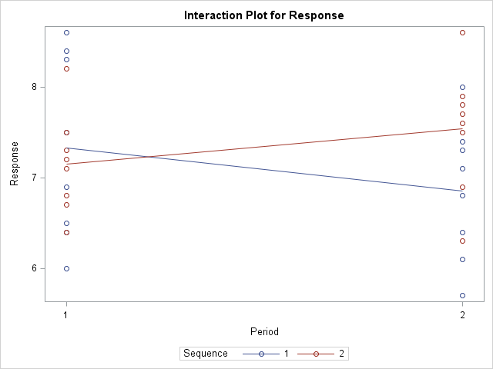

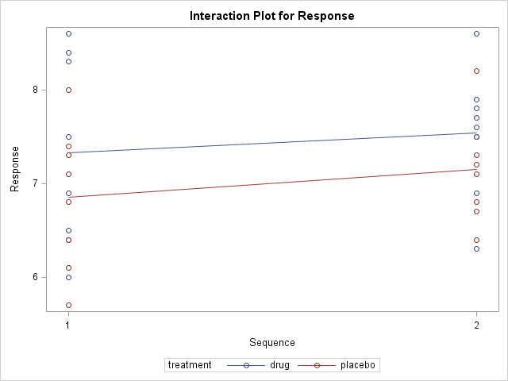

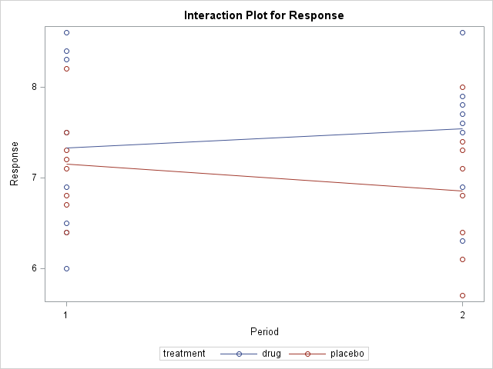

The drug is used in period 1-sequence 1 and period 2-sequence 2, which both shows a larger mean response. Further, in all three plots the drug treatment has a higher response regardless of period or sequence. Thus, we have evidence that the drug does influence mean response.

1. Run a repeated measures analysis of variance for this design. Draw conclusions. Does the analysis of variance confirm your impressions in part (b)?

|  |  |  |  |  |  |
| --- | --- | --- | --- | --- | --- |
| **Source** | **DF** | **Type III SS** | **Mean Square** | **F Value** | **Pr > F** |
| **Sequence** | 1 | 0.525312 | 0.525312 | 0.46 | 0.5070 |
| **Patient(Sequence)** | 14 | 15.861875 | 1.132991 | 20.03 | <.0001 |
| **Period** | 1 | 0.015313 | 0.015313 | 0.27 | 0.6110 |
| **treatment** | 1 | 1.487812 | 1.487812 | 26.30 | 0.0002 |
| **Error: MS(Error)** | 14 | 0.791875 | 0.056563 |  |  |